Name:______________________________________ Date:_______________
Mrs. Valdes/Mr. Craine

Directions: Using the sheet provided to you, make a poster to depict the Neolithic and the Paleolithic Age. You must include at least two illustrations for each and four facts listed by bullet points to describe each.

Example:
PALEOLITHIC AGE
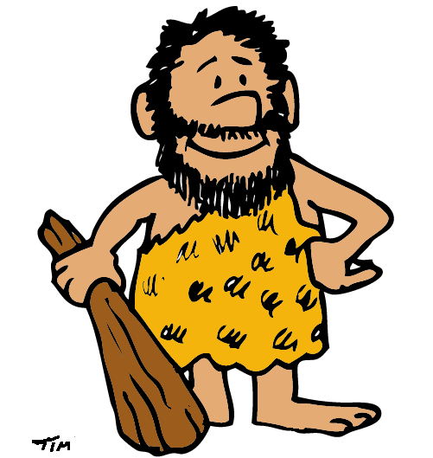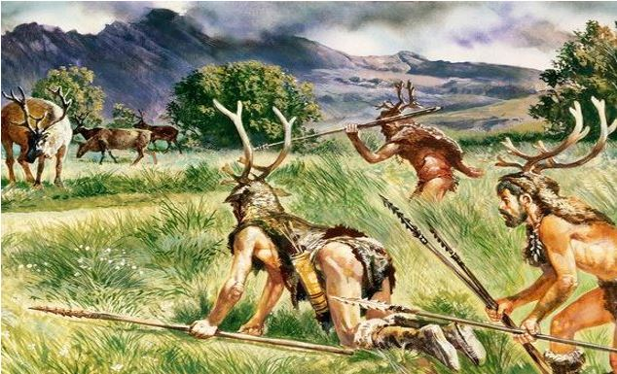
- Nomadic: People moved from place to place
- People were hunters and gatherers and did so in small groups
- There were gender roles: men were the hunters and women were the gatherers.
- People used simple tools and weapons: sticks for digging, spears, and axes out of stone, bone or wood.
NEOLITHIC AGE
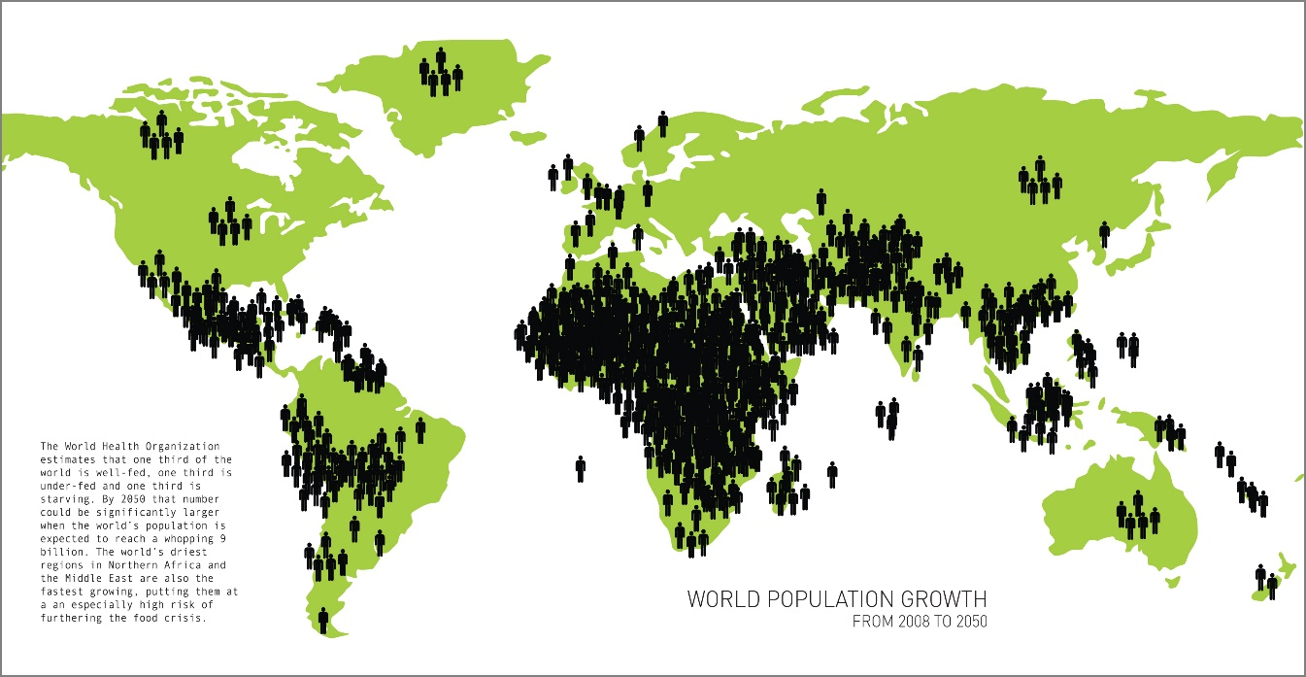
- Created permanent villages
- Domesticated or tamed animals
- Learned to farm
- Population grew

